

SPACE SHOOTING GAME

PROJECT REPORT

## Computer Science

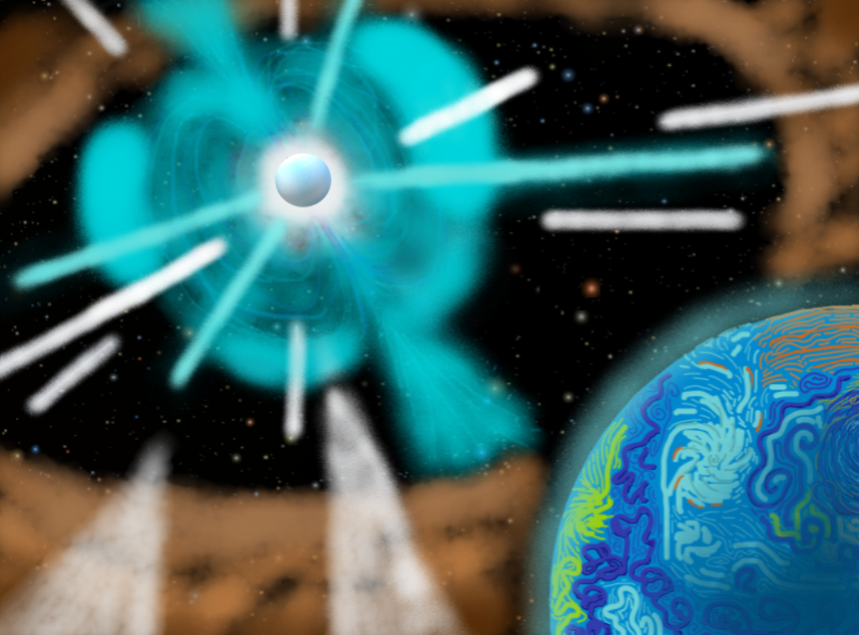

NAME: AAryan SHARMA

BOARD ROLL NO:

DPS INDIRAPURAM

## 2020-21

CERTIFICATE

This is to certify that Aaryan Sharma of class XII-D have prepared the project on the topic of “SPACE SHOOTING GAME”. The project is the result of their and their team’s efforts and endeavours. This project is found worthy of acceptance as the final project report for the subject computer science of class XII. They have prepared this project under my guidance.

Ms. Rinkoo Gupta

(Computer Science Teacher)

(DPS Indirapuram)

## ACKNOWLEDGEMENT

I would like to express a deep sense of gratitude towards my computer science teacher Ms. Rinkoo Gupta ma’am for guiding me though the course of my project. She always evinced keen interest in my work and her constructive advice and constant motivation have been responsible for the successful completion of this project.

My sincere thanks goes to Ms. Sangeeta Hajela, our school principal for her coordination in extending every possible support possible in the success of this project.

I would like to thank all those who have helped directly or indirectly in the completion of the project.

Aaryan Sharma

XII-D

**INDEX**

|  |  |  |
| --- | --- | --- |
| **S.NO.** | **TOPIC** | **REMARKS** |
| 1 | INTRODUCTION TO THE PROJECT |  |
| 2 | MySQL tables / CSV files used/ Binary files used and their structure |  |
| 3 | HARDWARE AND SOFTWARE REQUIREMENTS |  |
| 4 | CODING |  |
| 5 | OUTPUTS |  |
| 6 | CONCLUSION |  |
| 7 | FUTURE ENHANCEMENTS |  |
| 8 | BIBLIOGRAPHY |  |

1. INTRODUCTION TO THE PROJECT

Our CS Project “The Space Walker” is based on game development using PyCharm and Pygame, inspired by the old arcade game ‘Space Invaders’.

Upon beginning, the player interacts with the game by controlling a space ship with arrow keys and space bar.

The goal is to survive waves of enemies for as long as possible. The longer you survive, the harder the game becomes by increasing the level.

Each level has a greater number of enemies that need to be destroyed than the previous level. There’re 5 levels in total in the game, the last level being a boss battle of sorts.

The game is accompanied by a vivid and immersive display of background arts, character sprites (all self-drawn), and audio/music effects.

There’s a score system which is affected by the number of levels you clear, the number of times the player crashes or loses a life by allowing the enemy to pass the screen without being destroyed.

When then game ends, the high-score is displayed on the menu screen.

1. MySQL Tables / CSV / Binary Files used & Their Structure

Modules imported:

* Os.path – For saving data into text files.
* Random – For generating random spawn positions.
* Pygame – Running the modules to make a videogame.
* Pickle – for handling binary files.
* Mixer – For running mp3 files.

Files used:

* Text/Binary files (“score.txt” for storing high-scores.)
* PNG files (Storing images & sprites for the game.)
* Wav & mp3 files (storing music and sound effects.)

Layers, Time & Frame Rates:

* In order: (Start) Screen, Background, UI meters (Level, Lives & Crash), Enemies, Player, Win/Lost (End) Screen.
* Wav & mixer files executed by music.play() command.
* Pause function included, using time.Clock() command.

Contacts & UI (User Interference):

* Classes & Objects used for: Ships, Enemies, Player, and Lasers. Includes measuring dimensions of the images.
* Collision detected by distance function, set to Not None.
* Health bar feature, keeps tally of how many collisions are taking place with the Player.
* Enemy health = 1 hit-point, Player health = 10 hit-points.

1. SOFTWARE & HARDWARE REQUIREMENTS

HARDWARE: Intel Core i5 processor or higher.

SOFTWARE: One of the following Operating Systems:

* Microsoft Windows 8.8.1
* Microsoft Windows 7 SP 1
* Microsoft Windows Server 2012
* Microsoft Windows Server 2008 SP2 (IA-32 Only)
* Microsoft Windows Server 2008 R2 SP1
* Microsoft Windows HPC Server 2008

Compilers:

* Intel® C++ Compiler 13.1 (Intel® Parallel Studio XE 2013 SP 1) or higher.
* Microsoft Visual C++ 10.0 or higher.

1. CODING

import os.path

import pickle

import random

import pygame

from pygame import mixer

pygame.font.init()

pygame.init()

WIDTH, HEIGHT = 800, 600 # THE SCREEN SIZE

DIMENSIONS = pygame.display.set_mode((WIDTH, HEIGHT))

pygame.display.set_caption("The Space Walker") # THE GAME NAME

REDEX = pygame.image.load("REDEX.png") # ENEMIES

GENEX = pygame.image.load("GENEX.png")

BREX = pygame.image.load("BREX.png")

BOSS = pygame.image.load("Boss.png")

player = pygame.image.load("BLShip.png") # THE PLAYER

THESPACEWALKER = pygame.image.load("SPACEWALKER.png")

REDEXASER = pygame.image.load("REDEXASER.png") # ENEMY LASERS

GENEXASER = pygame.image.load("GENEXASER.png")

BREXASER = pygame.image.load("BREXASER.png")

BOSSXASER = pygame.image.load("BOSSXASER.png")

LAME = pygame.image.load("SPACEXASER.png") # PLAYER LASER

NEOXASER = pygame.image.load("NEOXASER.png")

BG = pygame.transform.scale(pygame.image.load("background.png"), (WIDTH, HEIGHT)) # GAME BACKGROUND

music = pygame.mixer.music.load('background.mp3') # GAME MUSIC

pygame.mixer.music.play(-1)

# FUNCTIONS BEING USED IN THE GAME # PAUSE FUNCTION

def pause():

paused = True

while paused:

pause_font = pygame.font.SysFont("freesansbold.ttf", 80)

con_font = pygame.font.SysFont("freesansbold.ttf", 80)

for event in pygame.event.get():

if event.type == pygame.KEYDOWN:

if event.key == pygame.K_c:

paused = False

pause_label = pause_font.render("Paused", 1, (255, 255, 255))

DIMENSIONS.blit(pause_label, (WIDTH / 2 - pause_label.get_width() / 2, 250))

con_label = con_font.render("C to Continue", 1, (255, 255, 255))

DIMENSIONS.blit(con_label, (WIDTH / 2 - con_label.get_width() / 2, 300))

pygame.mixer.pause()

pygame.display.update()

pygame.time.Clock()

class Laser:

def __init__(self, x, y, img):

self.x = x

self.y = y

self.img = img

self.mask = pygame.mask.from_surface(self.img)

def draw(self, window):

window.blit(self.img, (self.x, self.y))

def move(self, vel):

self.y += vel

def off_screen(self, height):

return not (height >= self.y >= 0)

def collision(self, obj):

return collide(self, obj)

class Ship:

COOLDOWN = 30

def __init__(self, x, y, health=100):

self.x = x

self.y = y

self.health = health

self.ship_img = None

self.laser_img = None

self.lasers = []

self.cool_down_counter = 0

def draw(self, window):

window.blit(self.ship_img, (self.x, self.y))

for laser in self.lasers:

laser.draw(window)

def move_lasers(self, vel, obj):

self.cooldown()

for laser in self.lasers:

laser.move(vel)

if laser.off_screen(HEIGHT):

self.lasers.remove(laser)

elif laser.collision(obj):

obj.health -= 10

self.lasers.remove(laser)

def cooldown(self):

if self.cool_down_counter >= self.COOLDOWN:

self.cool_down_counter = 0

elif self.cool_down_counter > 0:

self.cool_down_counter += 1

def shoot(self):

if self.cool_down_counter == 0:

laser = Laser(self.x - 17, self.y, self.laser_img)

self.lasers.append(laser)

self.cool_down_counter = 1

lsound = mixer.Sound('Lfire.wav')

lsound.play()

def get_width(self):

return self.ship_img.get_width()

def get_height(self):

return self.ship_img.get_height()

class Player(Ship):

def __init__(self, x, y, health=100):

super().__init__(x, y, health)

self.ship_img = player

self.laser_img = LAME

self.mask = pygame.mask.from_surface(self.ship_img)

self.max_health = health

def move_lasers(self, vel, objs):

self.cooldown()

for laser in self.lasers:

laser.move(vel)

if laser.off_screen(HEIGHT):

self.lasers.remove(laser)

else:

for obj in objs:

if laser.collision(obj):

colli = mixer.Sound('coll.wav')

colli.play()

obj.health -= 10

if laser in self.lasers:

self.lasers.remove(laser)

def draw(self, window):

super().draw(window)

self.healthbar(window)

def healthbar(self, window):

pygame.draw.rect(window, (255, 0, 0),

(self.x, self.y + self.ship_img.get_height() + 10, self.ship_img.get_width(), 10))

pygame.draw.rect(window, (0, 255, 0), (

self.x, self.y + self.ship_img.get_height() + 10,

self.ship_img.get_width() * (self.health / self.max_health),

10))

class Enemy(Ship):

COLOR_MAP = {

"red": (REDEX, REDEXASER),

"green": (GENEX, GENEXASER),

"blue": (BREX, BREXASER),

"black": (BOSS, BOSSXASER)}

def __init__(self, x, y, color, health=10):

super().__init__(x, y, health)

self.ship_img, self.laser_img = self.COLOR_MAP[color]

self.mask = pygame.mask.from_surface(self.ship_img)

def move(self, vel):

self.y += vel

def shoot(self):

if self.cool_down_counter == 0:

laser = Laser(self.x - 20, self.y, self.laser_img)

self.lasers.append(laser)

self.cool_down_counter = 1

if self.y > 0:

lsound = mixer.Sound('Lfire.wav')

lsound.play()

def collide(obj1, obj2):

offset_x = int(obj2.x - obj1.x)

offset_y = int(obj2.y - obj1.y)

return obj1.mask.overlap(obj2.mask, (offset_x, offset_y)) is not None

def text_objects(text, font):

textSurface = font.render(text, True, (0, 0, 0))

return textSurface, textSurface.get_rect()

def main():

run = True

FPS = 60

level = 0

lives = 3

crashed = 0

dict1 = {'score': 0}

main_font = pygame.font.SysFont("freesansbold.ttf", 50)

winc_font = pygame.font.SysFont("freesansbold.ttf", 70)

lost_font = pygame.font.SysFont("freesansbold.ttf", 70)

upgrad_font = pygame.font.SysFont("freesansbold.ttf", 30)

credit_font = pygame.font.SysFont("freesansbold.ttf", 30)

enemies = []

wave_length = 5

enemy_vel = 1

player_vel = 5

laser_vel = 3

player = Player(400 - 30, 500)

clock = pygame.time.Clock()

lost = False

lost_count = 0

winc = False

winc_count = 0

upgrad = False

upgrad_count = 0

upgraded = False

upgraded_count = 0

def redraw_window():

DIMENSIONS.blit(BG, (0, 0))

# draw text

lives_label = main_font.render(f"Lives: {lives}", 1, (255, 255, 255))

level_label = main_font.render(f"Level: {level}", 1, (255, 255, 255))

crashed_label = main_font.render(f"Crashed: {crashed}", 1, (255, 255, 255))

DIMENSIONS.blit(lives_label, (10, 10))

DIMENSIONS.blit(level_label, (WIDTH - level_label.get_width() - 10, 10))

DIMENSIONS.blit(crashed_label, (20, 550))

for enemy in enemies:

enemy.draw(DIMENSIONS)

player.draw(DIMENSIONS)

if lost:

pygame.mixer.music.pause()

LoseSound = mixer.Sound('LoseSound.wav')

LoseSound.play()

lost_label = lost_font.render("GAME OVER", 1, (255, 255, 255))

DIMENSIONS.blit(lost_label, (WIDTH / 2 - lost_label.get_width() / 2, 150))

crashed_label = main_font.render(f"You crashed: {crashed} times", 1, (255, 60, 60))

DIMENSIONS.blit(crashed_label, (WIDTH / 2 - crashed_label.get_width() / 2, 245))

credit_label = main_font.render(f"Game by (Aaditya & Aaryan) Sharma", 1, (255, 128, 0))

DIMENSIONS.blit(credit_label, (WIDTH / 2 - credit_label.get_width() / 2, 285))

credit1_label = main_font.render(f"Thank you for playing The Space Walker!", 1, (255, 128, 0))

DIMENSIONS.blit(credit1_label, (WIDTH / 2 - credit1_label.get_width() / 2, 320))

score_label = main_font.render(f"Score: {int(dict1['score']) - crashed}", 1, (255, 60, 60))

DIMENSIONS.blit(score_label, (WIDTH / 2 - score_label.get_width() / 2, 205))

credit2_label = credit_font.render(

"Music: 'Astra Lost in Space Theme' (from YouTube) - by Masaru Yokoyama.", 1, (255, 255, 0))

DIMENSIONS.blit(credit2_label, (WIDTH / 2 - credit2_label.get_width() / 2, 365))

credit3_label = credit_font.render(

"Background: 'Stars Background' (from Wallpapertip.com) - by Helena Ranaldi.", 1, (255, 255, 0))

DIMENSIONS.blit(credit3_label, (WIDTH / 2 - credit3_label.get_width() / 2, 390))

if winc:

pygame.mixer.music.pause()

WinSound = mixer.Sound('WinSound.wav')

WinSound.play()

winc_label = winc_font.render("You Win!", 1, (255, 255, 255))

DIMENSIONS.blit(winc_label, (WIDTH / 2 - winc_label.get_width() / 2, 150))

crashed_label = main_font.render(f"You crashed: {crashed} times", 1, (255, 60, 60))

DIMENSIONS.blit(crashed_label, (WIDTH / 2 - crashed_label.get_width() / 2, 245))

credit_label = main_font.render(f"Game by (Aaditya & Aaryan) Sharma", 1, (255, 128, 0))

DIMENSIONS.blit(credit_label, (WIDTH / 2 - credit_label.get_width() / 2, 285))

credit1_label = main_font.render(f"Thank you for playing The Space Walker!", 1, (255, 128, 0))

DIMENSIONS.blit(credit1_label, (WIDTH / 2 - credit1_label.get_width() / 2, 320))

score_label = main_font.render(f"Score: {int(dict1['score']) - crashed}", 1, (255, 60, 60))

DIMENSIONS.blit(score_label, (WIDTH / 2 - score_label.get_width() / 2, 205))

credit2_label = credit_font.render(

"Music: 'Astra Lost in Space Theme' (from YouTube) - by Masaru Yokoyama.", 1, (255, 255, 0))

DIMENSIONS.blit(credit2_label, (WIDTH / 2 - credit2_label.get_width() / 2, 365))

credit3_label = credit_font.render(

"Background: 'Stars Background' (from Wallpapertip.com) - by Helena Ranaldi.", 1, (255, 255, 0))

DIMENSIONS.blit(credit3_label, (WIDTH / 2 - credit3_label.get_width() / 2, 390))

if upgrad:

upgrad_label = upgrad_font.render("Your ship is being upgraded!", 1, (255, 255, 255))

DIMENSIONS.blit(upgrad_label, (WIDTH / 2 - upgrad_label.get_width() / 2, 270))

upgrad_label = upgrad_font.render("Survive this level!!", 1, (255, 255, 255))

DIMENSIONS.blit(upgrad_label, (WIDTH / 2 - upgrad_label.get_width() / 2, 290))

if upgraded:

upgraded_label = winc_font.render("Final Wave: Boss!!", 1, (255, 60, 60))

DIMENSIONS.blit(upgraded_label, (WIDTH / 2 - upgraded_label.get_width() / 2, 250))

upgraded_label = upgrad_font.render("HEALTH RESTORED!", 1, (0, 255, 0))

DIMENSIONS.blit(upgraded_label, (WIDTH / 2 - upgraded_label.get_width() / 2, 300))

upgraded_label = upgrad_font.render("Upgrade completed!", 1, (255, 255, 255))

DIMENSIONS.blit(upgraded_label, (WIDTH / 2 - upgraded_label.get_width() / 2, 330))

pygame.display.update()

while run:

clock.tick(FPS)

redraw_window()

if lives <= 0 or player.health <= 0:

lost = True

lost_count += 1

if lost:

if lost_count > FPS * 8.9:

run = False

else:

continue

if level < 6:

if len(enemies) == 0:

if level < 5:

dict1['score'] += 20

level += 1

wave_length += 1

for i in range(wave_length):

if level == 1:

enemy = Enemy(random.randrange(25, WIDTH - 80), random.randrange(-1200, -100),

random.choice(["blue"]))

enemies.append(enemy)

if level == 2:

enemy = Enemy(random.randrange(25, WIDTH - 80), random.randrange(-1200, -100),

random.choice(["red"]))

enemies.append(enemy)

if level == 3:

enemy = Enemy(random.randrange(25, WIDTH - 80), random.randrange(-1200, -100),

random.choice(["green"]))

enemies.append(enemy)

if level == 4:

enemy = Enemy(random.randrange(12, WIDTH - 80), random.randrange(-1200, -100),

random.choice(["red", "green", "blue"]))

enemies.append(enemy)

wave_length = 15

for i in range(wave_length):

if level == 5:

enemy_vel = 1.3

player.health = 100

player_vel = 3

player.ship_img = THESPACEWALKER

player.laser_img = NEOXASER

enemy = Enemy(random.randrange(0, WIDTH - 172), random.randrange(-1200, -100),

random.choice(["black"]))

enemies.append(enemy)

if level > 5:

winc = True

winc_count += 1

if level == 4:

upgrad = True

upgrad_count += 1

if winc:

if winc_count > FPS * 9:

run = False

else:

continue

if upgrad:

if upgrad_count > FPS * 3:

upgrad = False

else:

continue

if level == 5:

upgraded = True

upgraded_count += 1

if upgraded:

if upgraded_count > FPS * 2:

upgraded = False

else:

continue

if lost or winc:

f = open("score.dat", "ab")

score = dict1['score']

crashed = crashed

d = f'{score - crashed}\n'

pickle.dump(d, f)

f.close()

for event in pygame.event.get():

if event.type == pygame.QUIT:

quit()

keys = pygame.key.get_pressed()

if keys[pygame.K_LEFT] and player.x - player_vel > 0: # left

player.x -= player_vel

if keys[pygame.K_RIGHT] and player.x + player_vel + player.get_width() < WIDTH: # right

player.x += player_vel

if keys[pygame.K_SPACE]:

player.shoot()

if keys[pygame.K_p]:

pause()

for enemy in enemies[:]:

enemy.move(enemy_vel)

enemy.move_lasers(laser_vel, player)

if enemy.health == 0:

enemies.remove(enemy)

if random.randrange(0, 2 * 60) == 1:

enemy.shoot()

if collide(enemy, player):

player.health -= 10

enemies.remove(enemy)

crashed += 1

elif enemy.y + enemy.get_height() > HEIGHT:

lives -= 1

enemies.remove(enemy)

player.move_lasers(-laser_vel, enemies)

def button1():

mouse = pygame.mouse.get_pos()

if WIDTH / 2 - 75 + 150 > mouse[0] > WIDTH / 2 - 75 and 265 + 50 > mouse[1] > 265:

pygame.draw.rect(DIMENSIONS, (255, 128, 0), (WIDTH / 2 - 75, 265, 150, 50))

else:

pygame.draw.rect(DIMENSIONS, (255, 255, 255), (WIDTH / 2 - 75, 265, 150, 50))

smallText = pygame.font.Font("freesansbold.ttf", 20)

textSurf, textRect = text_objects("BLAST OFF!", smallText)

textRect.center = ((WIDTH / 2), (265 + (50 / 2)))

DIMENSIONS.blit(textSurf, textRect)

for event in pygame.event.get():

if WIDTH / 2 - 75 + 150 > mouse[0] > WIDTH / 2 - 75 and 265 + 50 > mouse[1] > 265:

if event.type == pygame.MOUSEBUTTONDOWN:

main()

def Score1():

if os.path.isfile("score.dat"):

d = open("score.dat", "rb") # d.closed == True, the file is open now.

n = 0

while True:

try:

rec = pickle.load(d)

print("Checking for start-up: " + rec)

n += 1

except EOFError:

d.close()

break

if n == 0:

pygame.draw.rect(DIMENSIONS, (255, 128, 0), (WIDTH / 2 - 100, 165, 200, 60))

pygame.draw.rect(DIMENSIONS, (255, 255, 255), (WIDTH / 2 - 95, 170, 190, 50))

smallText = pygame.font.Font("freesansbold.ttf", 20)

textSurf, textRect = text_objects(f"HIGH SCORE: 00", smallText)

textRect.center = ((WIDTH / 2), (170 + (50 / 2)))

DIMENSIONS.blit(textSurf, textRect)

print("EMPTY?! Who resetted the scores?!") # File is empty. Somebody erased the scores for a fresh start.

else:

f = open("score.dat", "rb")

n = 0

scr = []

while True:

try:

rec = pickle.load(f)

print("Reading from Bfile (rec): " + rec)

scr.append(rec)

n += 1

except EOFError:

f.close()

break

if n >= 2:

highscore = max(scr)

pygame.draw.rect(DIMENSIONS, (255, 128, 0), (WIDTH / 2 - 100, 165, 200, 60))

pygame.draw.rect(DIMENSIONS, (255, 255, 255), (WIDTH / 2 - 95, 170, 190, 50))

smallText = pygame.font.Font("freesansbold.ttf", 20)

textSurf, textRect = text_objects(f"HIGH SCORE: {highscore}", smallText)

textRect.center = ((WIDTH / 2), (170 + (50 / 2)))

DIMENSIONS.blit(textSurf, textRect)

print("True highscore") # This is how it should be.

elif n == 1:

highscore = scr[0]

pygame.draw.rect(DIMENSIONS, (255, 128, 0), (WIDTH / 2 - 100, 165, 200, 60))

pygame.draw.rect(DIMENSIONS, (255, 255, 255), (WIDTH / 2 - 95, 170, 190, 50))

smallText = pygame.font.Font("freesansbold.ttf", 20)

textSurf, textRect = text_objects(f"HIGH SCORE: {highscore}", smallText)

textRect.center = ((WIDTH / 2), (170 + (50 / 2)))

DIMENSIONS.blit(textSurf, textRect)

print("First play") # Played for the 1st time.

print("Reading of scr: ")

print(scr) # This tells me what the program reads from score.dat i.e. what all scores are saved now.

else:

pygame.draw.rect(DIMENSIONS, (255, 128, 0), (WIDTH / 2 - 100, 165, 200, 60))

pygame.draw.rect(DIMENSIONS, (255, 255, 255), (WIDTH / 2 - 95, 170, 190, 50))

smallText = pygame.font.Font("freesansbold.ttf", 20)

textSurf, textRect = text_objects(f"HIGH SCORE: 00", smallText)

textRect.center = ((WIDTH / 2), (170 + (50 / 2)))

DIMENSIONS.blit(textSurf, textRect)

print("Playing for the 1st time? Good luck!") # You've either resetted the scores or nobody has played yet.

def REScore1():

mouse = pygame.mouse.get_pos()

if WIDTH / 2 - 100 + 200 > mouse[0] > WIDTH / 2 - 100 and 365 + 50 > mouse[1] > 365:

pygame.draw.rect(DIMENSIONS, (100, 100, 100), (WIDTH / 2 - 100, 365, 200, 50))

else:

pygame.draw.rect(DIMENSIONS, (255, 255, 255), (WIDTH / 2 - 100, 365, 200, 50))

smallText = pygame.font.Font("freesansbold.ttf", 20)

textSurf, textRect = text_objects("Reset Highscore?", smallText)

textRect.center = ((WIDTH / 2), (365 + (50 / 2)))

DIMENSIONS.blit(textSurf, textRect)

for event in pygame.event.get():

if WIDTH / 2 - 100 + 200 > mouse[0] > WIDTH / 2 - 100 and 365 + 50 > mouse[1] > 365:

if event.type == pygame.MOUSEBUTTONDOWN:

f = open("score.dat", "rb+")

f.truncate()

f.close()

def start_screen():

run = True

while run:

DIMENSIONS.blit(BG, (0, 0))

button1()

Score1()

REScore1()

pygame.display.update()

for event in pygame.event.get():

if event.type == pygame.QUIT:

run = False

pygame.quit()

start_screen()

1. OUTPUTS

START-UP (first time):

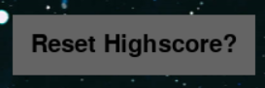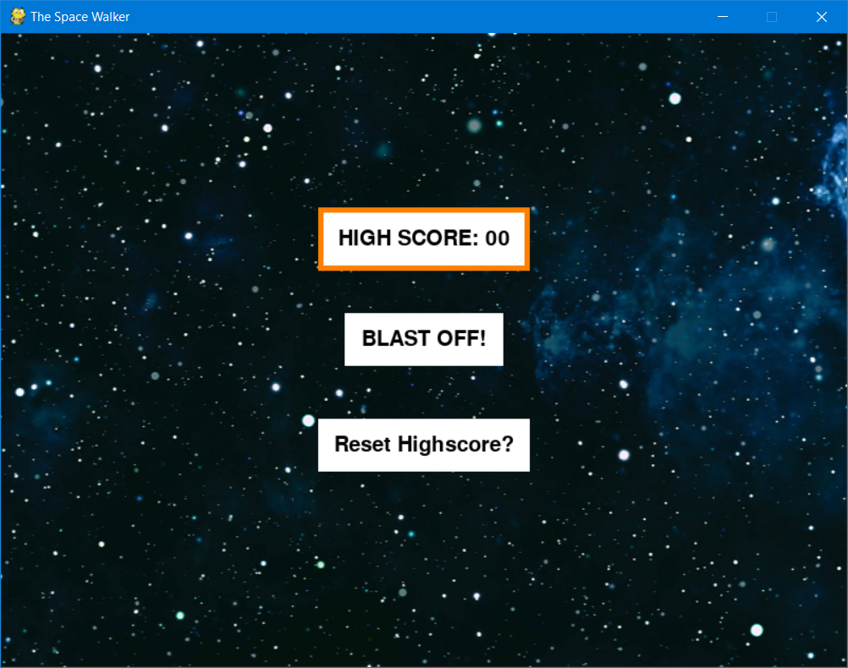

“Blast off!” first screen:

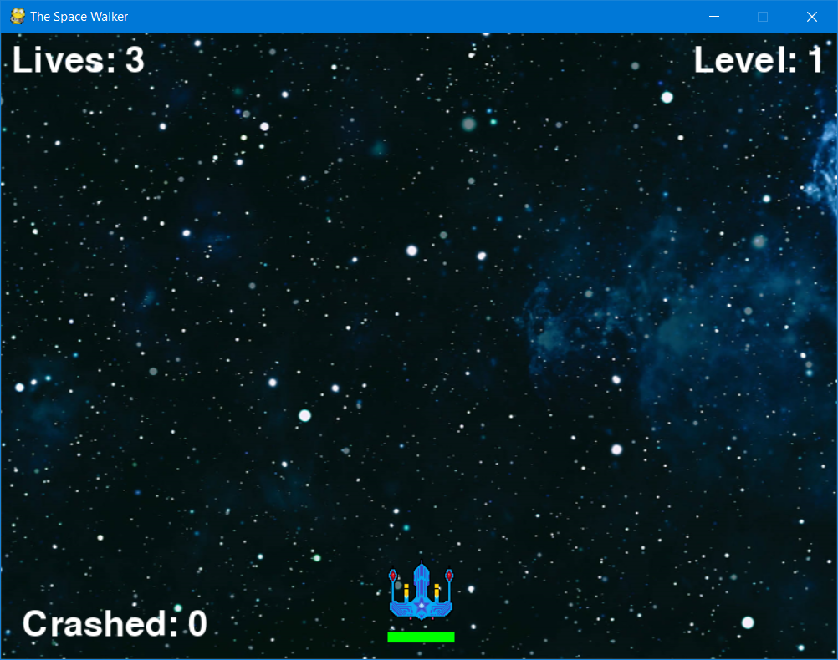

Level 1:

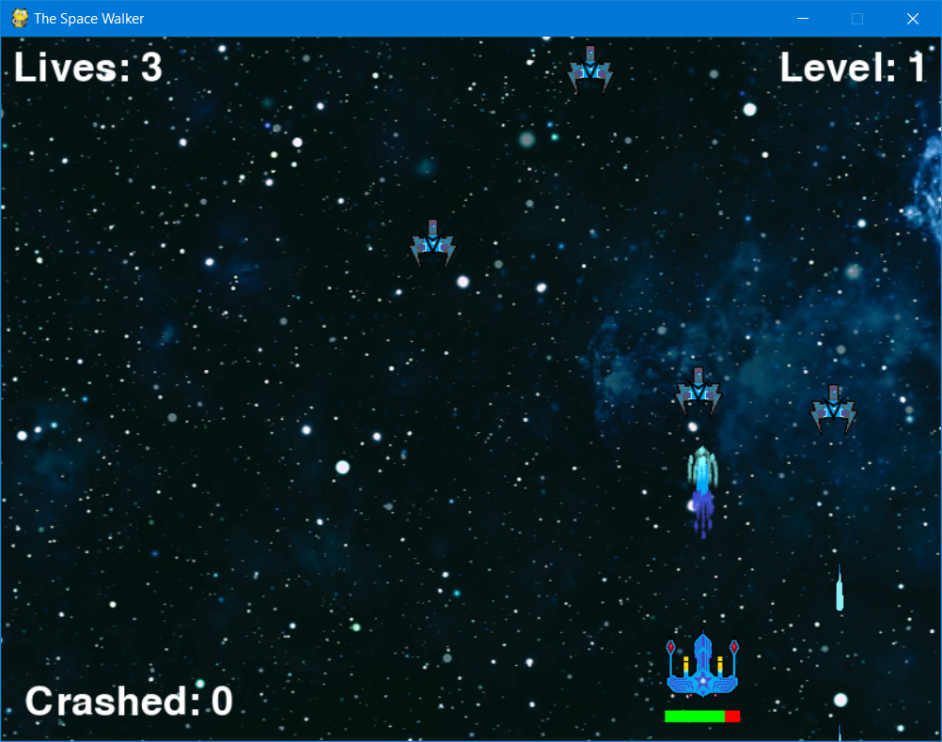

Level 2:

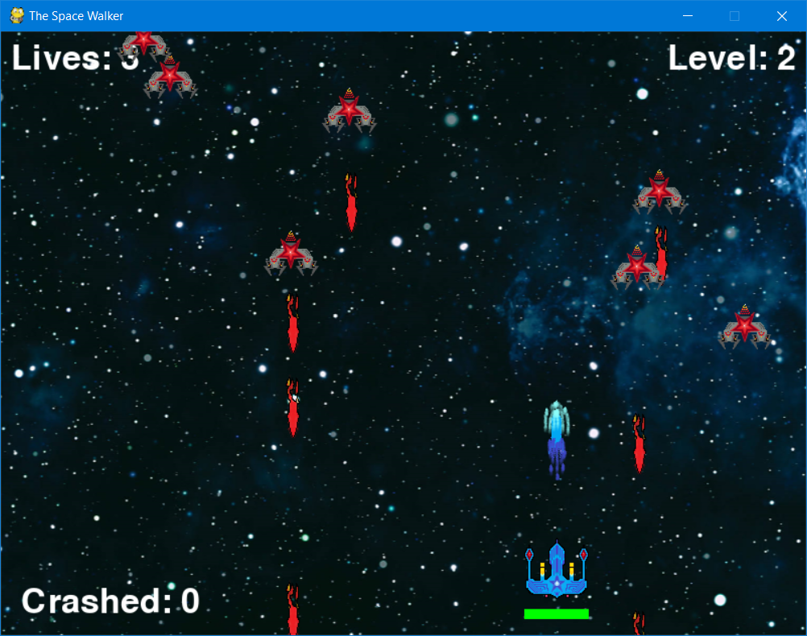

Level 3:

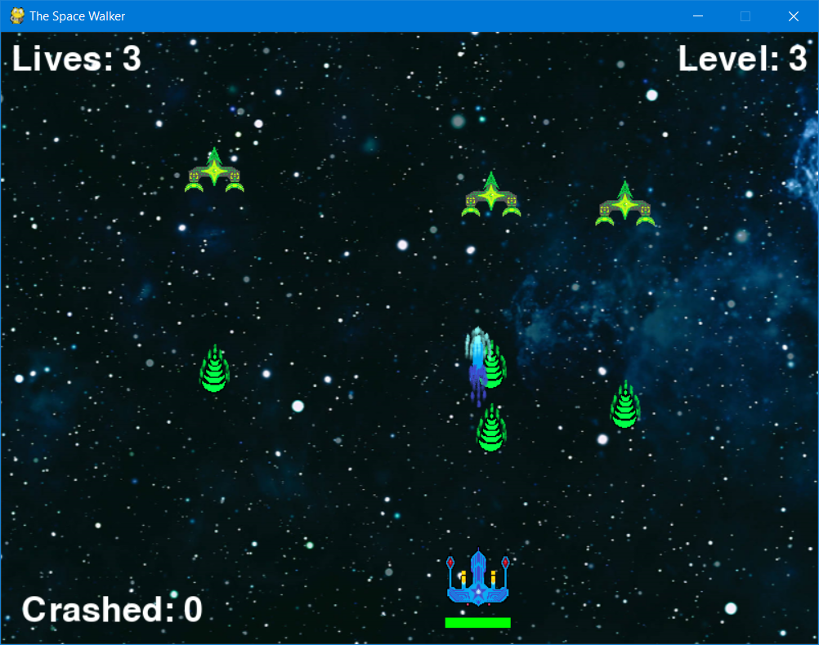

Mid-Notification (1):

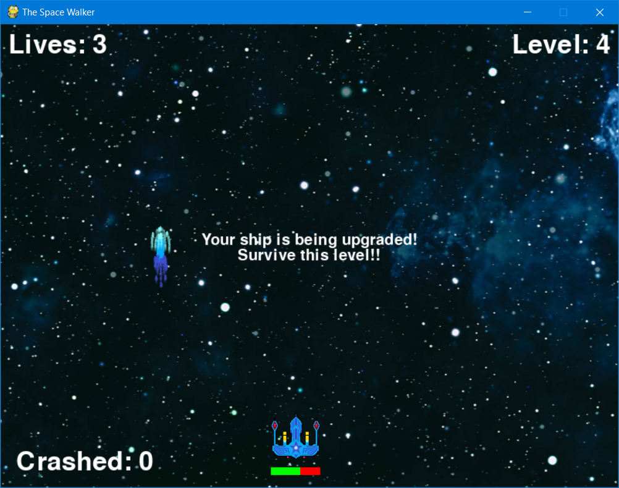

Pause Screen:

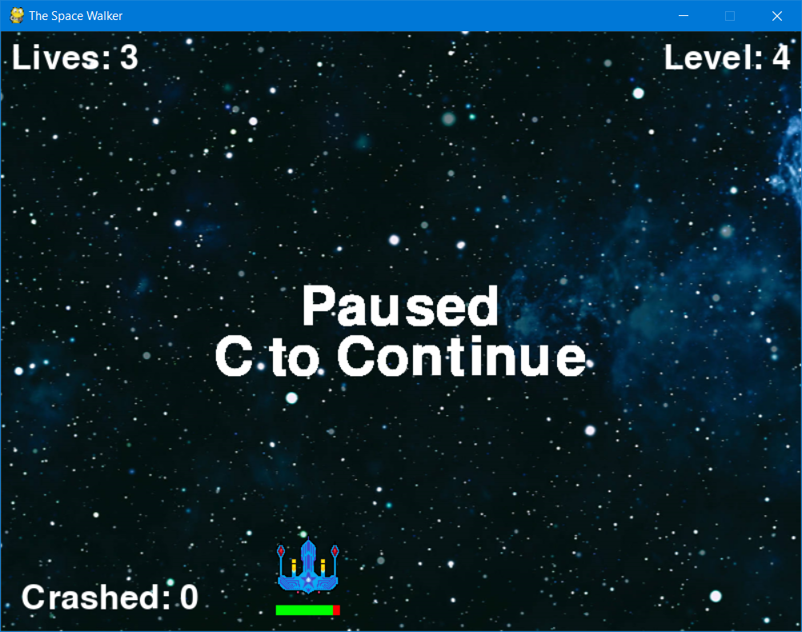

Level 4:

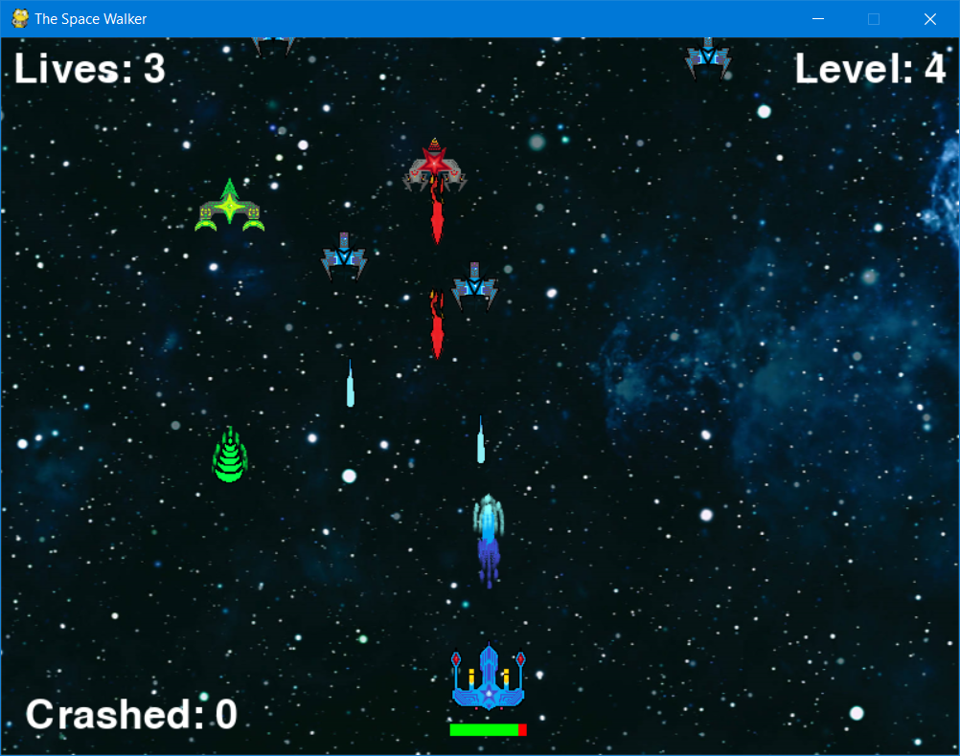

Mid-Notification (2):

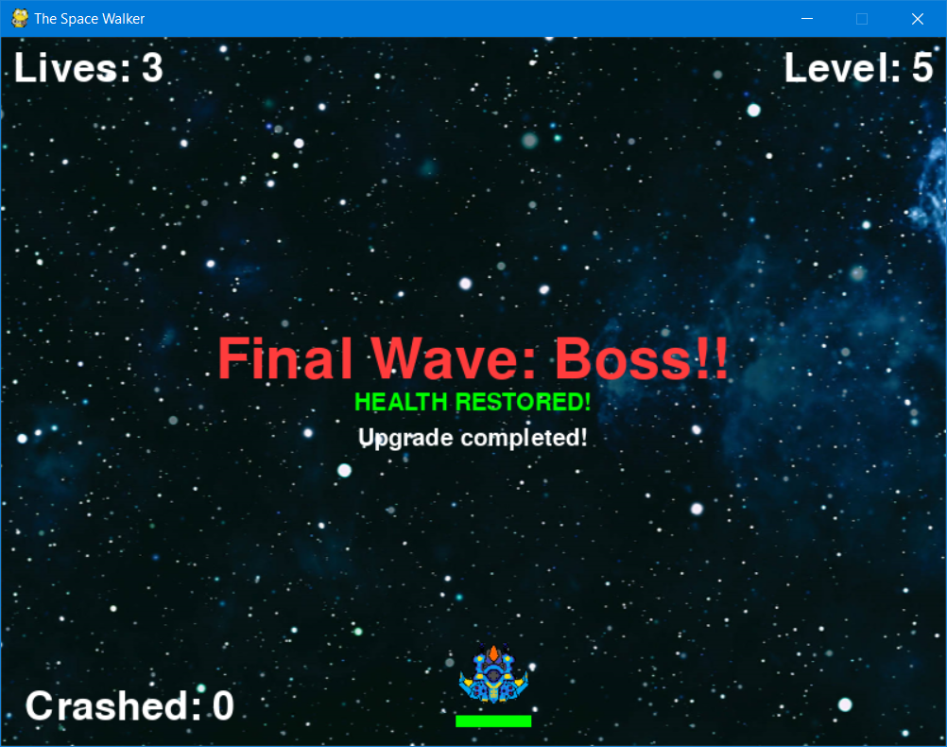

Level 5:

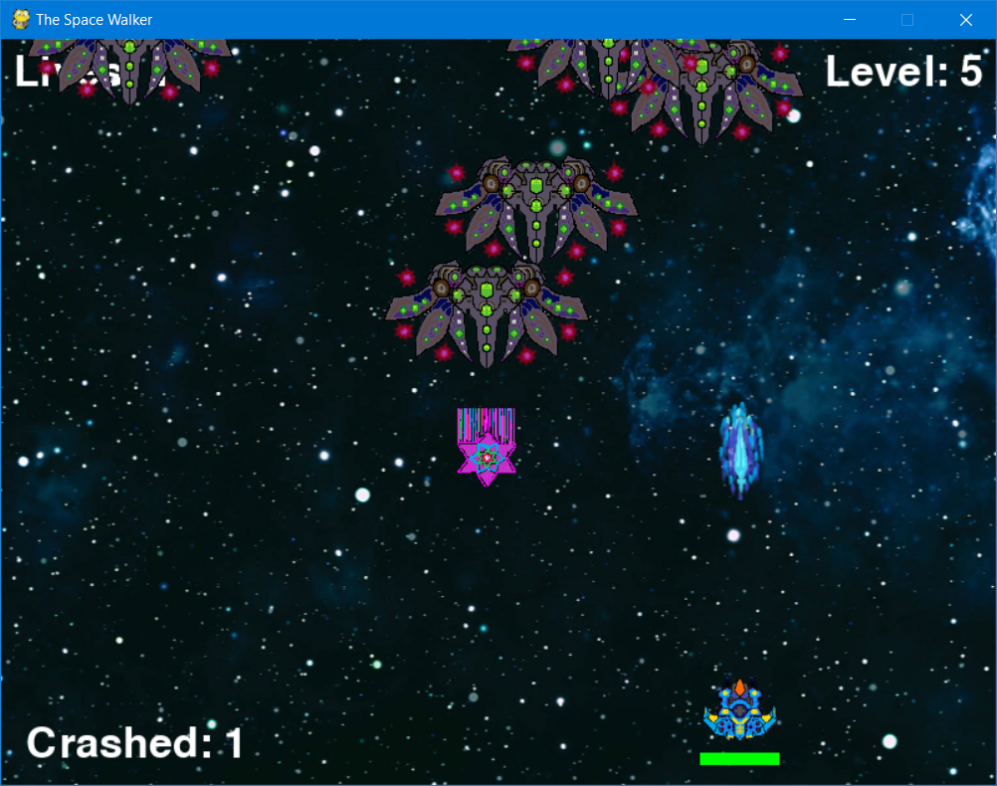

End (Lose) Screen:

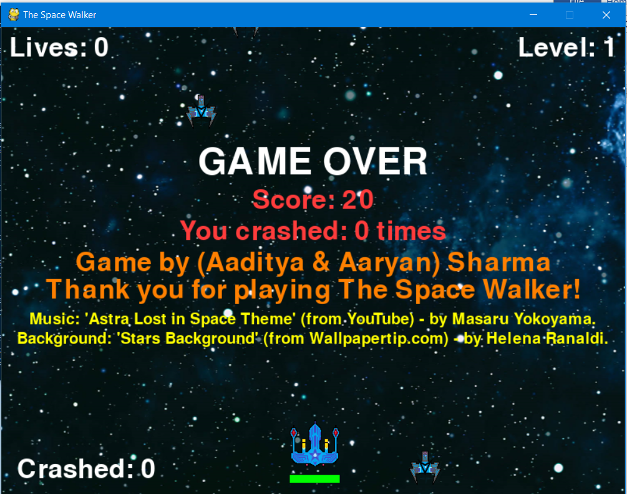

End (Win) Screen:

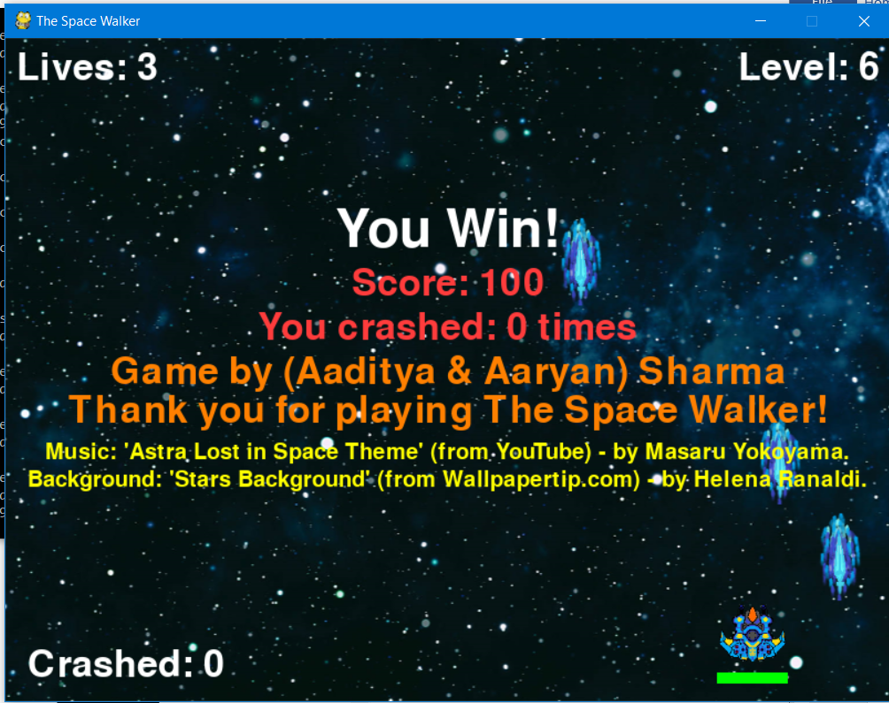

Menu Screen (Updated):

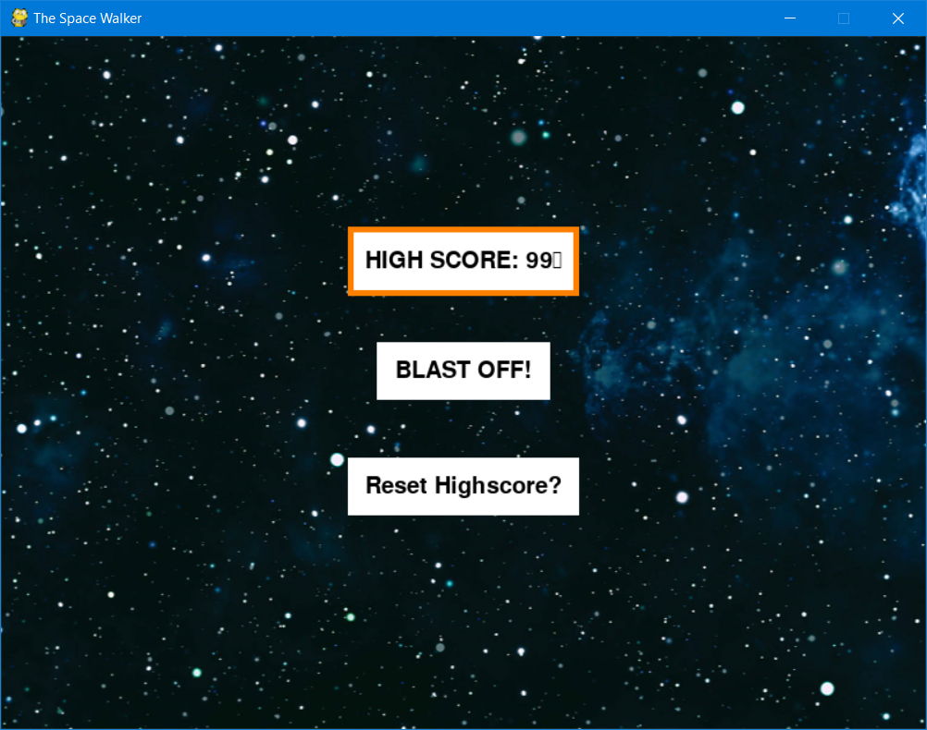

1. CONCLUSION

A game called ‘The Space Walker’ based off of the arcade game ‘Space Invaders’, developed using PyCharm and Pygame, and Python.

Project Synopsis:

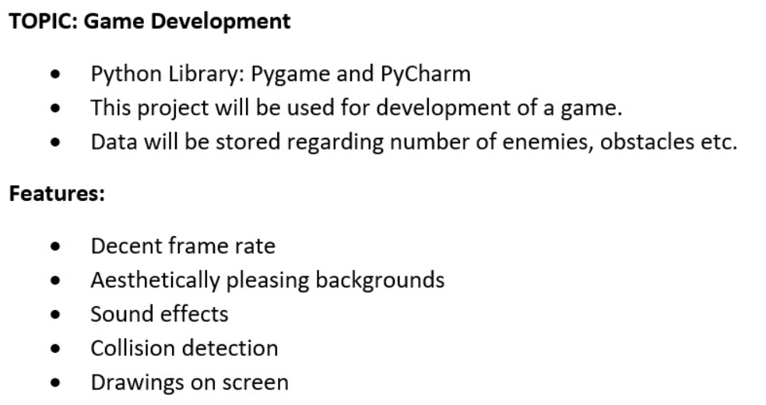

1. FUTURE ENHANCEMENTS

* The high score system has a limit, a maximum possible score per says, which ruins the purpose of a high score if any player achieves it.
* Bug-fixes: High score sometimes doesn’t display actual high score after the 2nd game, unless it’s on PyCharm.
* A player-account system which records the username and high-score to display the scores of players in a tabular format, in descending order, giving ranks accordingly.
* Better background and sprite artwork and soundtracks.
* A secret level that can be unlocked under special conditions.
* A story line/plot to not just have a casual game. To potentially make players more attracted to the game.
* Better UI.

1. BIBLIOGRAPHY

**Original help for saving highscore in python:**

<https://stackoverflow.com/questions/16726354/saving-the-highscore-for-a-python-game>.

**File Handling help:**

<https://stackoverflow.com/questions/82831/how-do-i-check-whether-a-file-exists-without-exceptions>.

**Class PPTs referred to (by Ms. Rinkoo Gupta):**

"File Handling"

"Numbers & Strings"

**Inspirations & other online references:**

[Pygame Tutorial - Creating Space Invaders](https://www.youtube.com/watch?v=Q-__8Xw9KTM).

[Game Development in Python 3 With Pygame - 1 - Intro](https://www.youtube.com/watch?v=ujOTNg17LjI).

[Python / Pygame Tutorial: Creating multiple stages in a game](https://www.youtube.com/watch?v=j9yMFG3D7fg).

[Game Development in Python 3 With Pygame - 14 - Button Function](https://www.youtube.com/watch?v=kK4xhHr1QeQ).

**Tools used along the way:**

MS Paint & Paint 3D

Audacity [All sound effects are from YouTube.]